Leek & Biddulph
Primary Care Network (PCN)
Patient Information Leaflet

Don’t forget to like us on Facebook to keep up to date! Leek and Biddulph PCN Facebook

Version 2.5
Valid From May 2023
Valid To May 2024

What is Leek and Biddulph Primary Care Network (PCN)?
- It is the five GP surgeries in Biddulph and Leek working together with a range of local providers, including community services, social care and the voluntary sector, to offer more personalised, coordinated health and social care.
- We are small enough to maintain the traditional strengths of general practice but at the same time large enough to provide resilience and support the development of new teams.
- We have a collective patient population of just over 50,000.
- There is recognition that the two geographic areas of Biddulph and Leek will at times have differing healthcare needs, and flexibility in health service provision has been built into the PCN design to accommodate for this.

What difference does the primary care network make to patients?
- We provide care in different ways to match different people’s needs. This includes access to advice and support for ‘healthier’ sections of the population, and joined up care for those with complex conditions.
- Extra services are offered locally at each GP Practice and there is no need to travel outside of your normal GP Practice area.
- We recruit extra specialist clinical staff to work alongside existing practice staff. Including Social Prescribers, Pharmacists, Dietitians, Occupational Therapists and Physiotherapists.
- We offer improved access to services and extend the range of current services available to you.

Values, Visions & Aims

Our Core Values
- We demonstrate respect and have high standards of integrity.
- We strive for continuous improvement.
- We welcome patient engagement.

Our Vision
- To bring better health care to residents in Leek & Biddulph.
- To improve the quality of life for our patients.

Our Aims
- To develop the GP practice teams and make them fit to take the NHS into the future.
- To use data, technology and local knowledge to find the best health care solutions.
- To work together to ensure that we provide good care for both patients and staff whilst continuing to maintain the independence and individuality of each member practice.

The following services are now available in your GP practice:

Clinical Pharmacist
Our clinical pharmacists answers questions about your medicines and how to get the best results for your health and lifestyle needs. They can support with:
- Medication side effects.
- Over the counter products.
- How to take different medications.
- Interactions with multiple medicines.
- Different ways to access your prescriptions.
Our pharmacy team advise on medication in the local care homes too. Please ask your GP Practice if you would like a Clinical Pharmacist to contact you.
Our Pharmacists are:
- Rajeet Dave
- Neha Zehra
- Noore Shazad
- Alice Wilson
- Bethany Cryer

Pharmacy Technician
Our pharmacy technicians help us to identify and prioritise patients who benefit the most from speaking to our pharmacists. They liaise with community pharmacies and make the whole process of ordering and collecting your prescription more efficient. They help reduce waste and support safety audits.

The Pharmacy Technicians are:
- Alison Ratcliffe
- Michelle Beech
- Hayley McCue

Social Prescribing Link Worker
Our social prescribers will talk with you to understand your needs and discuss what help and support is available. If you have a problem that is not medical, the social prescriber can connect you to appropriate support and find ways for you to feel more in control of your health and wellbeing and a part of your community.
Please ask your GP Practice if you would like a Social prescriber to contact you.
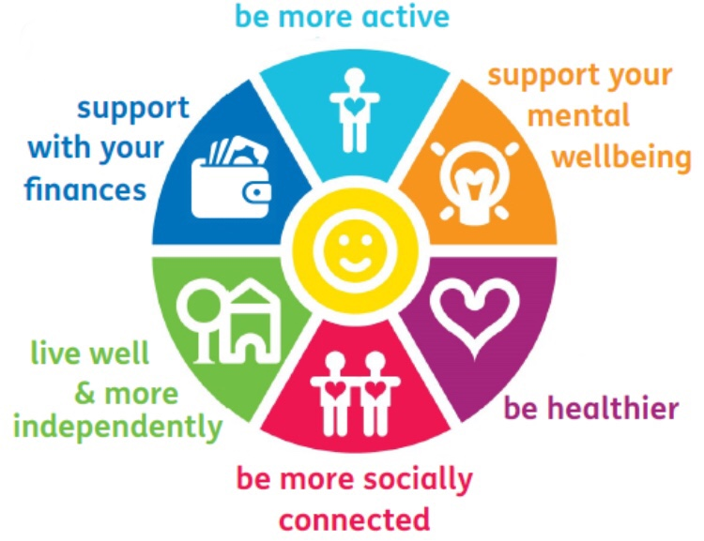
Our Social Prescribers are:
- Sarah Blore
- Amanda Dodd
- Victoria Lockett
- Laura Higgins
- Lianne Burton

Dietitian
Our Dietitian can:
- Provide dietary advise to help with weight reduction for patients with BMI>28kg/m² (18 – 50 years).
- Provide specialist advice on a therapeutic diet for long term health conditions (i.e., COPD, coeliac disease, hypertension, inflammatory bowel disease, poorly controlled Type 2 diabetes).
- Deliver tips on good nutrition and hydration to help minimize risks of falls among the frail and elderly.
- Provide carer education and support to care homes.

Please ask your GP Practice if you would like our Dietitian to contact you.

Our Dietitian is:

Ameyovi Agbotse

Occupational Therapist
Our Occupational Therapists can:
- Provide a holistic assessment for patients ages 16+.
- Enable patients living with a range of physical and mental health difficulties to overcome barriers which are preventing them from participating in daily activities.
- Provide an early intervention service to support independence and reduce disability that may be caused by health conditions.
- Work with patients to improve their health and wellbeing, particularly those with early frailty, those off work looking to return and those with early stages of mental health difficulties or cognitive impairment.
Please ask your GP Practice if you would like an Occupational Therapist to contact you.
Our Occupational Therapists are:

Vicky Jones
- Liz Smith
- Beth Dale

First Contact Physiotherapist
- A typical First Contact Physiotherapist appointment involves assessment, diagnosis and first-line management of musculoskeletal conditions.
- Your physiotherapist can arrange tests and investigations such as x-rays and blood tests and make referrals into secondary care services in the same way as GPs.
- This is a person-centered service, most appointments include self-management advice, social prescribing, and discussions about physical activity and fitness for work.
- We do not provide a course of physiotherapy treatment but can refer patients for a course of physiotherapy treatment if it is clinically appropriate.
- The service is only for patients aged 18+
Please ask your GP Practice if you would like a Physiotherapist to contact you.
Our Physiotherapists are:

Sabrina Welsh
- Adam Byrne

Mental Health Practitioner
Our Mental Health Practitioner service is:
- An ageless service for patients with a wide range of mental health needs.
- There to support patients to access the best service for their needs, by signposting or referring patients on.
The overall aim of the Mental Health Practitioner role is to provide a non-judgmental, supportive approach and to help patients gain quicker and easier access to the right service to support them in their recovery. Some patients may be offered additional or follow-up appointments, to review their progress and work on short term interventions.
Our Mental Health Practitioner has good links with other mental health services within the local area.
You will be contacted by our PCN Mental Health Practitioner if you are referred by your GP or another professional at the practice.
Our Mental Health Practitioner is:
- Claire Rothwell

Support Time Recovery worker (STRW)
Our STR worker service is:
- For patients with a wide range of Mental Health needs
- To support patients at home or in the local community.

The overall aim of STR worker is to look at providing support on Anxiety, low mood, social isolation, and emotional support. To support them in their recovery.
Our STR worker has links with other mental health services within local area and will contact you following referral by either a GP or Mental Health Practitioner.
Our Support Time recovery worker is:
- Heather Richardson

Care Co-Ordinator
The Care Co-ordinator ensures that your health and care planning is timely, efficient, and centred around you. This is achieved by bringing together all the information about your identified care and support needs and exploring options to meet these within a single personalised care and support plan, based on what matters to the patient.

Our Care Co Coordinators are:

Adele Bromley
- KaseyLee Clarke
- Natalie Galante
- Sara Davies

Our Management Team
Dr Neil Briscoe | Clinical Director
Dr Melody Bradley | Deputy Clinical Director
Lisa Dulson | Business Manager
Jenna Heath | IT & Business Intelligence Officer
Alison Ratcliffe | Project Manager
Our Admin and Support team
Holly Potts | PCN Support Officer
Paige Wain | Administration Assistant
Email – leek.biddulphpcn.nhs.net

Our GP Practices
Biddulphdoctors
Tel: 0300 404 2988 | www.biddulphdoctors.nhs.uk
Biddulph Primary Care Centre, Wharf Road, Biddulph, ST8 6AG

Biddulph Valley Surgery
Tel: 0300 404 2987 | www.biddulphvalleysurgery.nhs.uk
Biddulph Primary Care Centre, Wharf Road, Biddulph, ST8 6AG
Leek Health Centre
Tel: 01538 381022 | www.leekhealthcentre.co.uk
Fountain Street, Leek, ST13 6JB
Moorland Medical Centre
Tel: 01538 392490 | www.moorlandmedicalcentre.co.uk
Dyson House, Regent Street, Leek, ST13 6LU
Park Medical Centre
Tel: 01538 399152 | www.pmcleek.nhs.uk
Ball Hayes Road, Leek, ST13 6QR

